Chapter 10, Problem 68.

For the circuit in Fig. 10.111, obtain the Thèvenin equivalent at terminals a-b.

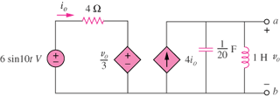

Figure 10.111
For Prob. 10.68.

